Population: set of all things that are of interest.

Sample: a smaller part of the population that we actually collect data on.

Observational study: observe and collect data, no influences or controls. Don’t draw cause and effects conclusions.

Right skewed: peaks at the Left of the graph.

Left Skewed: peaks at the Right.

Approximation Rule for a normal distribution: 68, 95, 99.7



Eq:

X value ⬄ eq ⬄ z score ⬄ Standard Normal Table ⬄ Probability

Parameter: property of an underlying probability distribution.

Sample Statistic: a number that describes a characteristic of the population. We use the sample statistic to make inferences about the population parameter. Because the value of the sample statistic changes based on which sample we choose, we call it a random variable. So things like the sample mean X, the sample standard deviation S, the sample proportion ^p, etc. are all random variables.

mu: the mean for the original population of individual values

sigma: the standard deviation for the original population of individual values

p: the proportion for the original population of individual values

x bar: the sample mean of the individual observations in a single sample

s: the sample standard deviation of the individual observations in a single sample

^p: the sample proportion of the individual observations in a single sample

Mu x bar: the theoretical mean for the population of all possible sample means

Sigma x bar: the theoretical standard deviation for the population of all possible sample means

SEx: (standard error of x bar) the sample estimate of the standard deviation for all possible sample means

Mu ^p: the theoretical mean for the population of all possible sample proportions

Sigma ^p: the theoretical standard deviation for the population of all possible sample proportions

SE^p: (standard error of ^p) the sample estimate of the standard deviation for all possible sample proportions

The Theoretical Population of All Possible Sample Means

Shape: Normal if pop is normal or our sample size is at least 30

Center: mu x bar = mu (the theoretical mean of all the possible sample means is equal to the original population mean)

Spread: sigma x bar = sigma/sqrt(n) (the theoretical standard deviation of all the possible sample means is equal to the original

population standard deviation divided by the square root of n)

The Theoretical Population of All Possible Sample Proportions

Shape: Normal if np >= 5 and n (1 - p) >= 5

Mean: mu ^p = p (the theoretical mean of all possible sample proportions is equal to the original population proportion)

Standard Deviation: sigma ^p =

(the theoretical standard deviation of all the possible sample proportions...)

Standard Error: S:E: (^p) =

(our estimate of sigma ^p using the sample proportion)

The Theoretical Population of All Possible Sample Counts

Shape: Normal if np >= 5 and n (1 - p) >= 5

Mean: mu X = np

Standard Deviation: sigma X = sqrt(np(1-p))



Probabilities for Sample Means:



Probabilities for Sample Count:

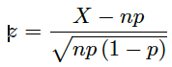Probabilities for Sample Count

Don't forget continuity correction

(add/subtract .5 as appropriate).

**Switch proportions to counts.

Assumption: np >= 5 and n (1 - p) >= 5

“We are 95% confident that the population mean ACT score, mu, of all students is between x and y.”

Z Confidence Interval for Population Mean mu (sigma is known):



condition: normal population or n _>=30

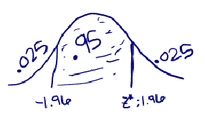

Margin of error: 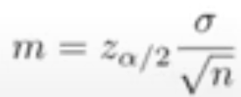

T Confidence Interval for Population Mean mu (sigma is unknown):

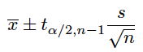

Degrees of freedom: n - 1

condition: normal population or n >= 30

Find sample size for desired margin of error

sample size for Z confidence interval for mean:

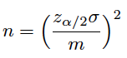

Review for Hypothesis Tests

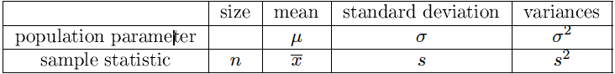

What I expect to see on each hypothesis test problem:

. Which test should you use?

. Choose significance level.

. Check the conditions (assumptions).

. What are the hypotheses?

. What is the test statistic?

. What is the p-value?

. Do you reject or fail to reject the null hypothesis?

. Interpret your conclusion.

One Sample Z Test (know population standard deviation sigma)

Condition: Normal Population or n >= 30

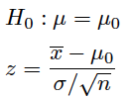

Doing a Z test with your calculator

I had you do the Z test by hand but now you can just put it in your calculator like you do the T test if you prefer.

One Sample T Test (know sample standard deviation s)

Condition: Normal Population or n >= 30

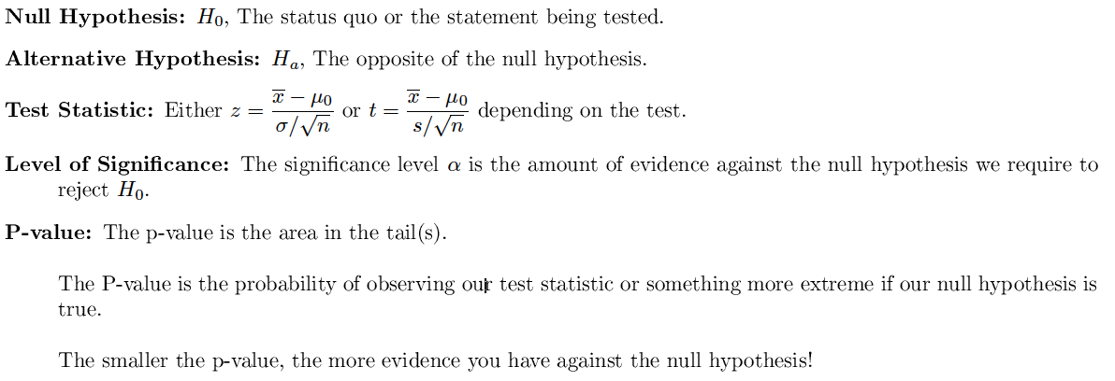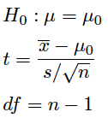

Type I Error: When we reject a true null hypothesis

Type II Error: When we fail to reject a false null hypothesis

Significance and P-values

The level of significance  tells us how much evidence we will require to reject the null hypothesis.

The p-value tells us how much evidence we actually found against the null hypothesis.

Statistical significance is different from practical significance.